Business Requirement Document (BRD) – Parakh Workflow Inspection Management System

CM Monit A, A+, Ghoshna & MLA Work Dashboards
(Prepared as CMMI Level 5 Guidelines)
Timeline – 12th September – UAT Deployment then after it will be Live Go Live

Introduction

- Project Name: Parakh – CM Monit A, A+, Ghoshna & MLA Work Dashboards Extension
- Prepared For: MPSeDC / Department Panchayat and Rural Development.
- Prepared By: Sr. BA Dheeraj Motiyani
- Date: 01.09.2025
- Version: v1.0

Purpose
To extend the MP MLA Work Dashboard functionality by designing and implementing:
- Separate dashboards for CM Monit A, CM Monit A+, and CM Ghoshna.
- Separate summary and survey reports for each.
- Enhancements in District report, Inspection view, and area categorization.

Scope
The scope covers:
- Dashboards for monitoring works under CM Monit A, CM Monit A+, and CM Ghoshna.
- Summary reporting on Column Conditions such as by cost brackets limit, duplication, type of work, administrative hierarchy.
- Inspection and survey management with new filter dropdowns.
- Updating district-level reports and classification fields.

Objectives
- Provide CM Monit works separately from MLA works.
- Facilitate decision making with dedicated dashboards and reports.
- Improve survey inspection work accountability and government audit readiness.

Stakeholders

- Primary Users:
  - RES Department
  - CEO Zila Panchayat, Janpad Panchayat officials
  - Department Inspectors & Survey teams
- Secondary Users:
  - District & State-Level Admin
  - Data team
  - Read-only dashboard view Users

Functional Requirements
(Sample Understanding of the scenarios)
- Dashboard Creation
  - Separate dashboards for CM Monit A, CM Monit A+, and CM Ghoshna.
  - KPIs: ( Sample KPIs can also vary) –
At Upload (it will not have data change) but at report level KPI changes reflected
    - No. of works > ₹15 lakh
    - No. of works < ₹15 lakh
    - No. of duplicate works
    - No. of works surveyed
    - Works by Janpad Panchayat
    - Works by CEO Zila Panchayat
- Summary Reports
  - One report per dashboard (CM Monit A, A+, Ghoshna).
  - Must include: cost-based distribution, inspection status, duplication, survey details.
- District Report Updates
  - Modify and update existing district report with new CM work categories.
- Inspection Page Enhancements
  - Single dropdown filter for selecting MP/MLA/CM Monit A/A+/Ghoshna.
  - For CM filters: remove Vidhan Sabha & Lok Sabha fields.
- Area Type Update
  - “क्षेत्र का प्रकार” field to include CM Ghoshna label.
  - Works listed under CM Monit A/A+/Ghoshna to appear separately in dashboards & reports.
- Data Upload / Integration
  - Capability to upload work lists (e.g., CM Ghoshna works) and map them automatically.

5. Non-Functional Requirements (NFRs)
- Performance: Dashboard loads within <10 seconds for up to 50,000 records.
- Security: Role-based access for CM Cell, MLA, District officials.
- Scalability: Must handle future schemes without redesign.
- Accessibility: WCAG 2.1 compliant UI User Interface experience.

6. Business Rules
- Duplicate works must be flagged automatically.
- Cost brackets are hard thresholds (>15 lakh, <15 lakh).
- Inspection reports must sync with GIS data.
- Data updates to be reflected in dashboards within 2 hours.

7. Assumptions & Dependencies
- Source data provided by Department Panchayat and Rural Development.
- List of CM Monit A/A+ works will be delivered in CSV/Excel.
- Existing MLA dashboard framework reused for CM dashboards.

8. Constraints
- Must align with GoMP MPSeDC policies.
- Must integrate with existing Parakh GIS & Reporting modules.

9. Milestones & Deliverables ( These Tentative Deadlines )
- Documentation Dashboard mockups & approval – Day 1
- Development – Day 2-6
- UAT to RES team – Day 7
- Go-Live – Day 8

Business Requirement Traceability Matrix (BRTM)
Req ID | Requirement Description | Source | BRD Section | Design Ref | Test Case ID | UAT Status
FR-001 | Create CM Monit A dashboard | RES Meeting 01.09.25, Docx | 4.1 | Dashboard UI Spec | TC-001 | Pending
FR-002 | Create CM Monit A+ dashboard | Same as above | 4.1 | Dashboard UI Spec | TC-002 | Pending
FR-003 | Create CM Ghoshna dashboard | Same as above | 4.1 | Dashboard UI Spec | TC-003 | Pending
FR-004 | Separate summary report per dashboard | Docx | 4.2 | Reporting Spec | TC-004 | Pending
FR-005 | District report updation & modification | Docx | 4.3 | District Report Spec | TC-005 | Pending
FR-006 | Dropdown filter for MP/MLA/CM Monit | Docx | 4.4 | Inspection UI Spec | TC-006 | Pending
FR-007 | Remove Vidhan Sabha/Lok Sabha fields in CM filter | Docx | 4.4 | Inspection UI Spec | TC-007 | Pending
FR-008 | Add CM Ghoshna to “क्षेत्र का प्रकार” | Docx | 4.5 | Data Dictionary | TC-008 | Pending
NFR-001 | Dashboard response < 5 sec | BRD Sec. 5 | Performance Benchmarks | TC-NFR-001 | Pending
NFR-002 | WCAG 2.1 accessibility compliance | BRD Sec. 5 | Accessibility Checklist | TC-NFR-002 | Pending

=====================================================================================
Sample Wireframe
Preparation of CM Monit Work Dashboard Like this dashboard of MP MLA Work –
- Below CM Monit A, CM Monit A+, and CM Ghoshna Dashboards needs to be created separately
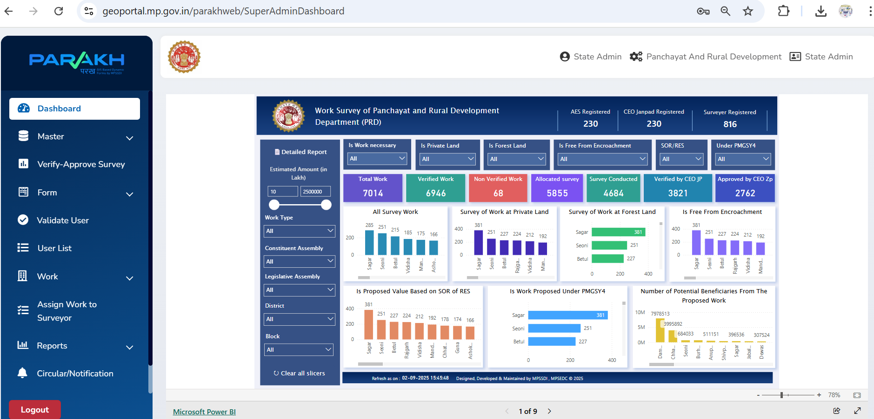
2) For those dashboards - 3 separate summary Reports needs to be created.
with different conditions ( Like No of Works >15 lakh, No of works <15, No of duplicate works, No of works surveyed, No of Janpad work , No of CEO zila panchayat work, and other columns etc…)
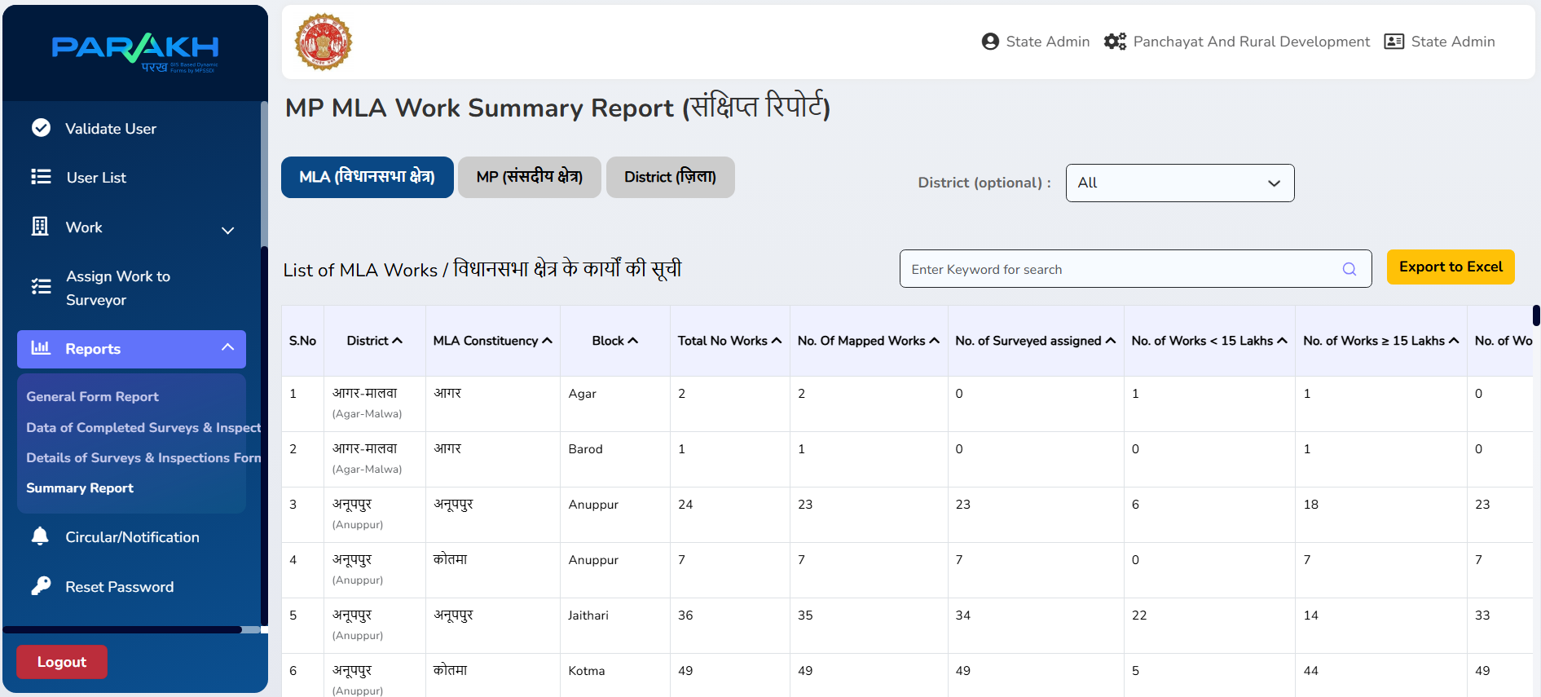

- District report updation and modification required
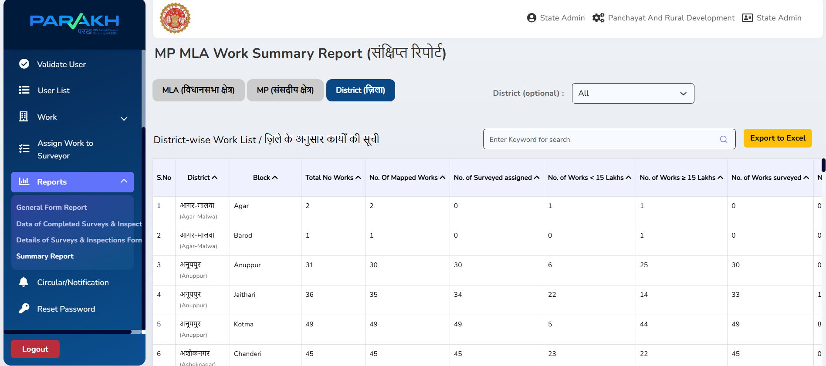
- In View Inspection page – one drop down filter required for all ( MP, MLA, CM Monit A, CM Monit A+, and CM Ghoshna) where for CM pages vidhan sabha lok sabha fields needs to be removed or updated.
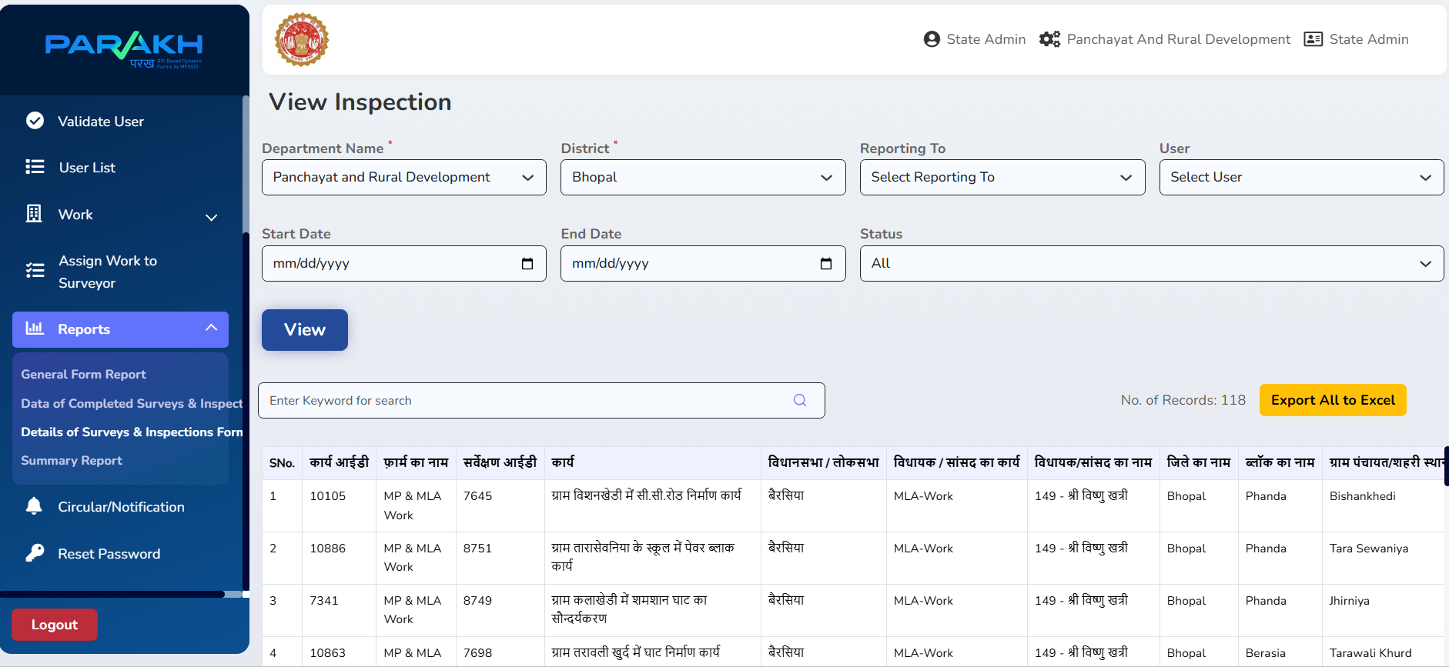

- In MP MLA work Report “Type of area” needed to be updated according to CM Monit related work
